**Charity Funding Predictor Analysis**

**Overview**

In this analysis we are given a CSV containing more then 34k organizations that have received funding from Alphabet Soup over the years. We would be using in machine leaning to help select the applicants for funding with the best chance of success in their ventures and we would be creating a binary classifier that can predict whether applicants will be successful if funded by Alphabet Soup.

**Data pre-processing**

First the dataset was clean by removing the not required information

1. The “EIN” and “NAME” column was dropped due to them not been a feature.
2. The remaining column would use as a feature for the model. Which I then found out the unique values for each column.
3. The CLASSIFICATION and APPLICATION_TYPE column was replaced due to high fluctuations. The data was then split into training and test sets of data.
4. For this model the “IS_SUCCESSFUL” column was the target variable and was verified by the values of 1 as YES and 0 as No.
5. The CLASSIFICATION column values was used for binning.
6. APPLICATION column data was analysed.
7. The binning was tested to see if it was successful.
8. Then pd.get_dummies() was used to encode categorical variables.

**Compiling, Training, and Evaluating the Model:**

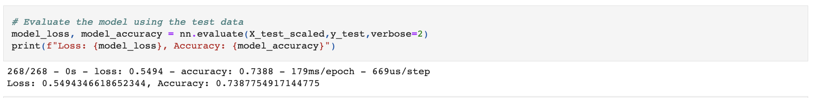

After multiple tries, I used the above values as it was the closets, I got to the target model performance.

I tried multiple times but was not able to get the accuracy above 74%.

To increases the model performance, I tried to increase the epochs, number of nodes, and using different activation types, I even tried decreasing the number of features.

**Summary**

**In summary I do believe more data is need and more layers and more trail and error is needed to be done to get a higher accuracy results.**